Practice 1 — Foundations API
Part C: AI report
November 2026
Authors: Antonio García Vicente, Gabriel Martín Jiménez
Course: Web Application Programming (G247)
Repository: github.com/gabrielmartin-cmd/CUNEF-FC
Tools: Claude (chat) and Claude Code in VS Code, with access to the repository

Note on evidence. The prompts in this report are simulated reconstructions; the original AI conversations were not preserved. What the agent produced, and what we kept, changed or rejected, is backed by our repository: 15 commits carry the trailer Co-Authored-By: Claude Opus 5.5, which Claude Code adds when it makes a commit [L1], and every claim below links to its commit.

How we used AI
We used Claude Code inside VS Code, with access to the repository, for most of Parts A and B, and Claude in the chat for reviews and explanations. For each task, the table shows what we kept, changed or rejected, and why.
Task · part · date | What the agent produced | What we kept, changed or rejected, and why | Evid.
Front-end review · B · 24/09 | A prioritised review guide for our HTML/CSS: nested <body> tags, a 0.1rem universal margin, accessibility fixes, and renaming every file to lowercase. | Kept the fixes: skip-link, aria-current and focus styles are still in the final site. Rejected the renaming: the links were changed but the files were not, so the logo broke; we restored LogoCunefFC.PNG and the original names. | L2, L3
Redesign · B · 01/10 | Styles.css rewritten (398 → 1,081 lines) with a custom skill stored in the repo: keep the club palette, mobile-first, never touch JS, no frameworks. | Kept. The result follows every rule of the skill: same palette, min-width breakpoints, prefers-reduced-motion, two web fonts. | L4, L5
Express skeleton, Session 4 · A · 08–14/10 | Server structure, the missing routes and the error handler, then explanatory comments in every file. | Changed: the controller was renamed to tasksController.js to match the brief, and /health, /echo/:msg and /boom were added to complete the brief’s checklist. The comments revealed an unused "main" field, which we removed two minutes later. | L6–L8
First own resources · A · 22/10 | Routers and controllers for players, matches and teams that copy the tasks pattern, as we asked. | Changed later: it only listed and echoed a POST, because our prompt did not state the status-code contract (§3). Full CRUD came on 07/11. Kept the foreign keys teamId, homeTeamId, awayTeamId. | L9
Database · A · 29/10 | A SQLite version of the data layer. | Rejected for now: the lecturer asked for no database yet. We moved it to futuro-bd/ with the steps to bring it back and kept in-memory arrays. | L10
Practice 1 API · A · 07/11 | The restructure to the brief’s layout, one validator per resource, store.js, six CRUDs, the filter and /stats. | Kept the layers. Changed: a 400 went from the first error { error } to all errors { errors: [{ field, message }] }; players.status became the boolean injured; /tasks, CORS and the lab routes were removed. The rule data/ in .gitignore was hiding src/data/ and became /data/ (Fig. 1). Keeping the optional JWT login was our decision. | L11–L14
Front end and tests · A, B · 07/11 | apiRequest() as the only fetch, ui.js with loading, error and empty states and per-field errors, a Postman collection and npm test. | Changed: every innerHTML went (32 uses on 29/10, none now) in favour of createElement + textContent; npm start became node src/server.js, as the brief requires. Kept the tests after running them (Fig. 2). | L15, L16

Advantages of the agent
- Speed. One session on 07/11 restructured the repo and delivered validators, store, six CRUDs, the pages and the tests in seven commits [L11–L16]; on 14/10 the Session 4 lab was completed and commented in seven minutes [L6–L8].
- Finding bugs we had not seen. With data/ in .gitignore, store.js would never have reached GitHub and npm start would fail on a clean clone (Fig. 1). The review found nested <body> tags [L2].
- Generating tests and requests. npm test checks status codes, Location, the error format and the filters, 28 checks (Fig. 2); the Postman collection has 12 requests on {{baseUrl}} [L16].
- Explaining the code for the defence. Comments in every file [L7]; the router explains why /stats must be declared before /:id. We checked it: swapping the two lines makes GET /api/players/stats answer 404 “Player not found”.
- A limit we learned. The agent does exactly what it is asked: a vague request gave a partial CRUD [L9]. That is the prompt we improved in §3.

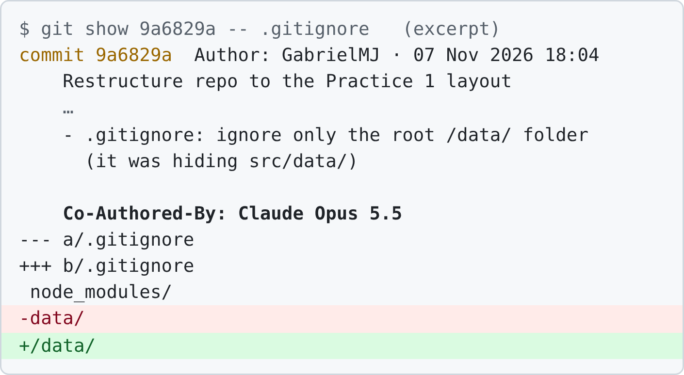  Fig. 1. Commit 9a6829a, made by Claude Code: the .gitignore fix (excerpt of git show) [L11]. | 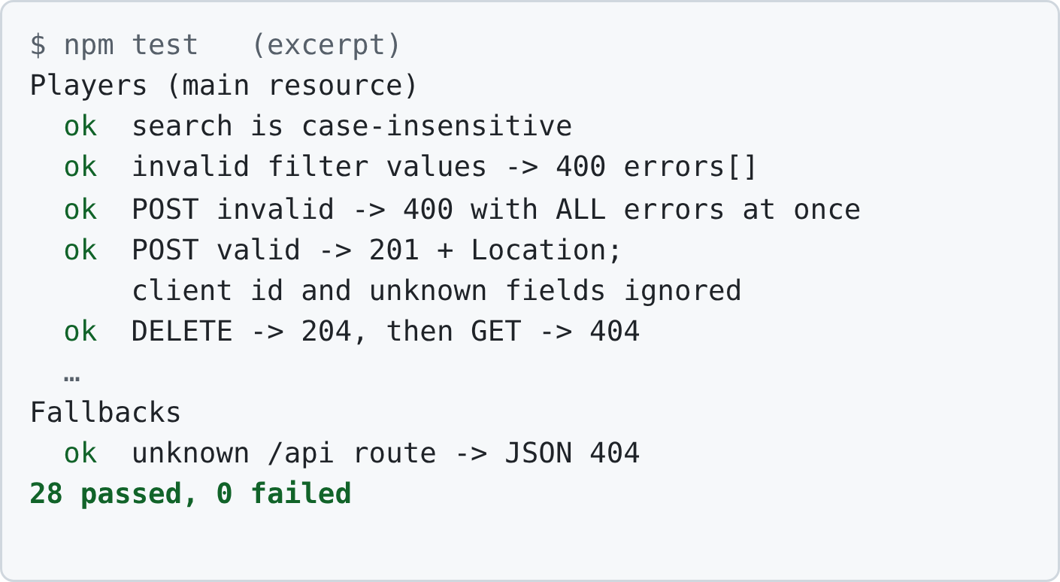  Fig. 2. npm test, written by the agent, run on the final code: 28 passed (excerpt) [L16].

A good prompt
We use the request of 22/10 (row 4 of the table). Both versions are simulated, in Spanish, the language we prompt in.

Weak first version (simulated)
Para el lab de la sesión 5 hemos modelado nuestras entidades: players, matches y teams. Un jugador pertenece a un equipo, y un partido tiene un equipo local y otro visitante. Crea un router y un controlador para cada una igual que el de tasks, con datos de ejemplo en memoria, y móntalos en app.js.
Result: the agent copied the tasks pattern: a list and an echo POST, with no GET /:id, PUT, DELETE, 404, 400 or Location header [L9].

Improved version, as we would write it now (simulated, in full)
Contexto: API REST en Express del club CUNEF FC; capas routes → controllers → datos en memoria. Recurso players: { id: lo genera el servidor; name: texto de 1 a 50; shirtNumber: entero de 1 a 99; position: goalkeeper | defender | fullback | midfielder | forward; injured: true o false; teamId: id de un equipo que exista }. Tarea: CRUD completo de players en src/routes/players.js y src/controllers/playersController.js. Contrato: GET / → 200 con el array · GET /:id → 200 o 404 · POST → 201 + Location: /players/:id, o 400 · PUT /:id → 200 (sustituye el jugador entero), 400 o 404 · DELETE /:id → 204 sin body, o 404. Un 400 devuelve { errors: [ { field, message } ] } con todos los errores a la vez; el id del cliente y los campos desconocidos se ignoran. Restricciones: sin librerías, CommonJS, no cambies nombres de funciones ni otros archivos, comentarios en español. Formato de salida: antes del código, la lista de casos de error que vas a cubrir; después, 1) los dos archivos completos, 2) una tabla petición → código esperado, 3) un comando curl por caso.

Why it works
- Context: the resource shape and the layers, so the agent does not invent fields or skip a layer.
- Constraints: the status-code contract turns “like tasks” into a checkable spec; no libraries, no other files and fixed names keep the change small and explainable.
- Output format: the files plus a request → expected-code table and one curl command per case, so we can verify every case at once. Listing the error cases before coding makes the agent reason step by step. Our redesign skill follows the same structure: role, mandatory workflow, constraints and response format [L5].

Links
All links point to github.com/gabrielmartin-cmd/CUNEF-FC; any commit can also be opened at …/commit/<hash>.
[L1] Commit history (15 commits co-authored by Claude) | [L9] ce553a2 · first own resources
[L2] b521ec2 · review guide applied | [L10] futuro-bd/LEEME.md · database deferred
[L3] 6c2b12f · logo reference restored | [L11] 9a6829a · restructure, .gitignore fix
[L4] 37ab1e9 · redesign of Styles.css | [L12] 23448aa · validators and 400 format
[L5] SKILL.md · redesign skill | [L13] 8b989b0 · store.js
[L6] 8a3c1c1 · Session 4 lab completed | [L14] ae1ed17 · 6 CRUDs, filter, /stats
[L7] 006f67b · explanatory comments | [L15] ab3fd7d · pages connected with fetch
[L8] 4c6da00 · unused "main" removed | [L16] f2eda01 · Postman collection, npm test

Conversations we did recover
[C1] https://claude.ai/share/cceca7ee-283a-4435-ac59-6ac6ae982c5e
[C2] https://claude.ai/share/d12e1908-6caa-4eeb-91f0-0d9787a9f300
[C3] https://claude.ai/share/5f1b2b6d-d88a-4fe2-89a4-f8496bd41ceb

